Austin Smothers

CSC 140

Asymptotic Analysis



Divide each side by n2 yields: 0 ≤ 5 ≤ c 🡪 c ≥ 5; n0 = 1



Divide each side by n yields: 0 ≤ n ≤ c 🡪 c ≥ 1; n0 = 1



Divide each side by n2 yields: 0 ≤ c ≤ 5 🡪 c ≤ 5; n0 = 1



Divide each side by n yields: 0 ≤ c15n ≤ 1 ≤ c25n 🡪 0 ≤ c1 ≤ 1/5n ≤ c2 🡪   
 There is no value combination for n0 and c2 such that c2 ≥ 1/5n is true.



a = 2; b = 3; Solve yields: 0 ≤ 1 ≤ c 🡪 c ≥ 1; n0 = 1

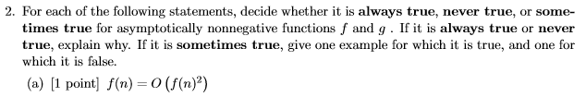

**Always true**, as f(n) O(f(n)2)



**Always true**, as the highest order between f(n) and g(n) is the only relevant one for the purposes of  notation. Therefore, the highest order of magnitude of f(n) + g(n) = the highest order of magnitude between f(n) & g(n).



0 ≤ c(g(n)) ≤ f(n) AND 0 ≤ f(n) < c(g(n)) is **never true**.

c(g(n)) > f(n) ≥ c(g(n)) cannot be true, as c(g(n)) > c(g(n)) must be false



100n2 < 2n 🡪 10n < 2n/2 🡪 Brute force from here  
 n = 14 yields 140 < 128 (false); n = 15 yields 150 < ~181  
 **n = 15**



n3/1000 - 100n2 - 100n + 3 = (n3)



2n+1 = O(2n) for c ≥ 2; n0=1  
 22n ≠ O (2n), as 22n-1 ≤ c is false, as c would have to be infinite.